# Install and load necessary packages

library(ggplot2)

library(dplyr)

library(ggplot2)

library(mosaic)

library(car)

library(readr)

library(corrplot)

wine_data <- read_csv("C:/Users/stdnt/Downloads/Questions-10018981011/winequality-red.csv")

View(wine_data)

# Summary statistics

summary(wine_data)

# Check column names

colnames(wine_data)

# Ensure correct column names

# If needed, adjust the column names to match your actual dataset

colnames(wine_data) <- c("fixed_acidity", "volatile_acidity", "citric_acid", "residual_sugar", "chlorides", "free_sulfur_dioxide", "total_sulfur_dioxide", "density", "pH", "sulphates", "alcohol", "quality")

# Check column names again

colnames(wine_data)

**#Ans1 Correlation Between Acidity and Quality:**

# Now try the correlation again

cor(wine_data$fixed_acidity, wine_data$quality)

# Correlation between alcohol concentration and quality

cor(wine_data$alcohol, wine_data$quality)

**#Ans2 Impact of Alcohol concentration on Quality:**

# Plotting

ggplot(wine_data, aes(x = alcohol, y = quality)) +

geom_point() +

geom_smooth(method = "lm", se = FALSE, color = "blue") +

labs(title = "Relationship Between Alcohol and Quality",

x = "Alcohol Content",

y = "Quality")

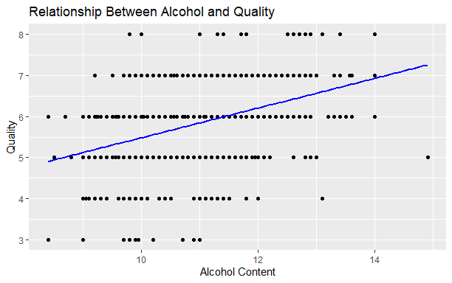

**#ans3 Impact of Sulphur Dioxide on Preservation:**

# Correlation between sulfur dioxide concentration and quality

cor(wine_data$total_sulfur_dioxide, wine_data$quality)

# Plotting

ggplot(wine_data, aes(x = total_sulfur_dioxide, y = quality)) +

geom_point() +

geom_smooth(method = "lm", se = FALSE, color = "green") +

labs(title = "Relationship Between Sulphur Dioxide and Quality",

x = "Total Sulfur Dioxide",

y = "Quality")

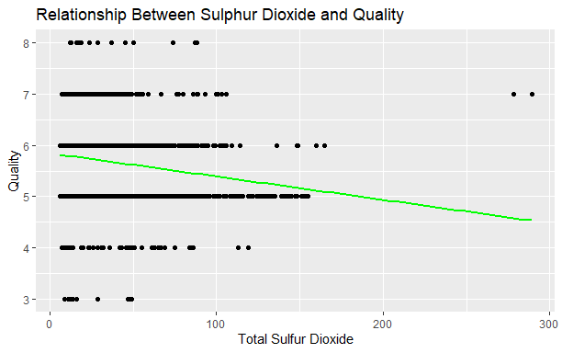

#Ans4 Citric Acid's Influence on Flavour Profile:

# Correlation between citric acid and quality

cor(wine_data$citric_acid, wine_data$quality)

# Plotting

ggplot(wine_data, aes(x = citric_acid, y = quality)) +

geom_point() +

geom_smooth(method = "lm", se = FALSE, color = "purple") +

labs(title = "Relationship Between Citric Acid and Quality",

x = "Citric Acid",

y = "Quality")

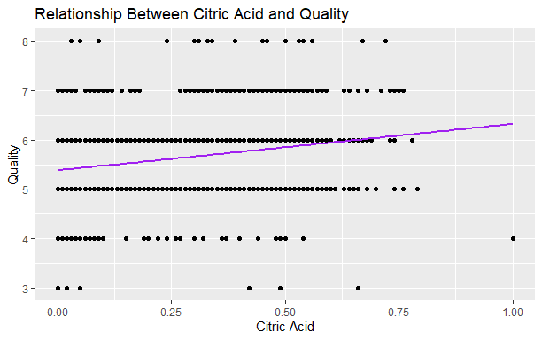

**#Ans5 Effect of Chlorides on Taste:**

# Correlation between chlorides and quality

cor(wine_data$chlorides, wine_data$quality)

# Plotting

ggplot(wine_data, aes(x = chlorides, y = quality)) +

geom_point() +

geom_smooth(method = "lm", se = FALSE, color = "orange") +

labs(title = "Relationship Between Chlorides and Quality",

x = "Chlorides",

y = "Quality")

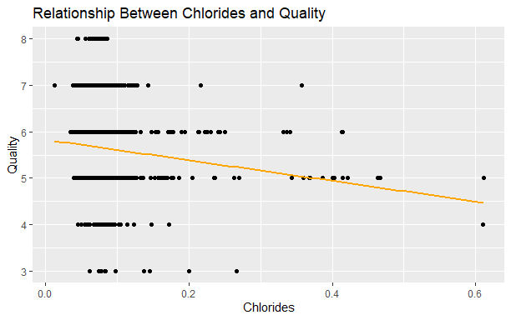

**#Ans6 Density and pH Relationship:**

# Correlation between density and pH

cor(wine_data$density, wine_data$pH)

# Plotting

ggplot(wine_data, aes(x = density, y = pH)) +

geom_point() +

geom_smooth(method = "lm", se = FALSE, color = "brown") +

labs(title = "Relationship Between Density and pH",

x = "Density",

y = "pH")

